Given an integer, convert it to a roman numeral.

Input is guaranteed to be within the range from 1 to 3999.

提交版本：

public class Solution {

public String intToRoman(int num) {

int a = num%10;

String s1 = "";

switch(a) {

case 1 : s1 = "I"; break;

case 2 : s1 = "II"; break;

case 3 : s1 = "III";break;

case 4 : s1 = "IV"; break;

case 5 : s1 = "V"; break;

case 6 : s1 = "VI"; break;

case 7 : s1 = "VII"; break;

case 8 : s1 = "VIII"; break;

case 9 : s1 = "IX"; break;

case 0 : break;

}

if(num/10 == 0) return s1;

else {

String s2 = "";

int b = (num/10)%10;

switch(b) {

case 1 : s2 = "X"; break;

case 2 : s2 = "XX"; break;

case 3 : s2 = "XXX";break;

case 4 : s2 = "XL"; break;

case 5 : s2 = "L"; break;

case 6 : s2 = "LX"; break;

case 7 : s2 = "LXX"; break;

case 8 : s2 = "LXXX"; break;

case 9 : s2 = "XC"; break;

case 0 : break;

}

if(num/100 == 0) return s2+s1;

else {

String s3 = "";

int c = (num/100)%10;

switch(c) {

case 1 : s3 = "C"; break;

case 2 : s3 = "CC";break;

case 3 : s3 = "CCC"; break;

case 4 : s3 = "CD"; break;

case 5 : s3 = "D"; break;

case 6 : s3 = "DC"; break;

case 7 : s3 = "DCC"; break;

case 8 : s3 = "DCCC"; break;

case 9 : s3 = "CM"; break;

case 0 : break;

}

if(num/1000 == 0) return s3+s2+s1;

else {

String s4 = "";

int d = (num/1000)%10;

switch(d) {

case 1 : s4 = "M"; break;

case 2 : s4 = "MM";break;

case 3 : s4 = "MMM"; break;

}

return s4+s3+s2+s1;

}

}

}

}

}

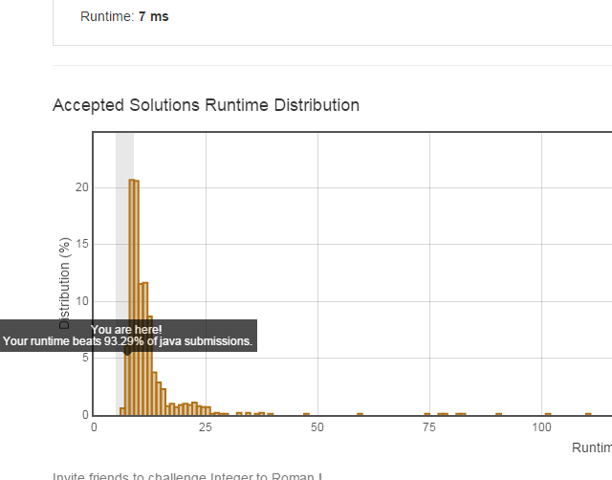

带测试版本：

**public** **class** IntegertoRoman {

**public** String intToRoman(**int** num) {

**int** a = num%10;

String s1 = "";

**switch**(a) {

**case** 1 : s1 = "I"; **break**;

**case** 2 : s1 = "II"; **break**;

**case** 3 : s1 = "III";**break**;

**case** 4 : s1 = "IV"; **break**;

**case** 5 : s1 = "V"; **break**;

**case** 6 : s1 = "VI"; **break**;

**case** 7 : s1 = "VII"; **break**;

**case** 8 : s1 = "VIII"; **break**;

**case** 9 : s1 = "IX"; **break**;

**case** 0 : **break**;

}

**if**(num/10 == 0) **return** s1;

**else** {

String s2 = "";

**int** b = (num/10)%10;

**switch**(b) {

**case** 1 : s2 = "X"; **break**;

**case** 2 : s2 = "XX"; **break**;

**case** 3 : s2 = "XXX";**break**;

**case** 4 : s2 = "XL"; **break**;

**case** 5 : s2 = "L"; **break**;

**case** 6 : s2 = "LX"; **break**;

**case** 7 : s2 = "LXX"; **break**;

**case** 8 : s2 = "LXXX"; **break**;

**case** 9 : s2 = "XC"; **break**;

**case** 0 : **break**;

}

**if**(num/100 == 0) **return** s2+s1;

**else** {

String s3 = "";

**int** c = (num/100)%10;

**switch**(c) {

**case** 1 : s3 = "C"; **break**;

**case** 2 : s3 = "CC";**break**;

**case** 3 : s3 = "CCC"; **break**;

**case** 4 : s3 = "CD"; **break**;

**case** 5 : s3 = "D"; **break**;

**case** 6 : s3 = "DC"; **break**;

**case** 7 : s3 = "DCC"; **break**;

**case** 8 : s3 = "DCCC"; **break**;

**case** 9 : s3 = "CM"; **break**;

**case** 0 : **break**;

}

**if**(num/1000 == 0) **return** s3+s2+s1;

**else** {

String s4 = "";

**int** d = (num/1000)%10;

**switch**(d) {

**case** 1 : s4 = "M"; **break**;

**case** 2 : s4 = "MMM";**break**;

**case** 3 : s4 = "MMM"; **break**;

}

**return** s4+s3+s2+s1;

}

}

}

}

**public** **static** **void** main(String ards[]){

System.***out***.println(**new** IntegertoRoman().intToRoman(0));

System.***out***.println(**new** IntegertoRoman().intToRoman(9));

System.***out***.println(**new** IntegertoRoman().intToRoman(19));

System.***out***.println(**new** IntegertoRoman().intToRoman(99));

System.***out***.println(**new** IntegertoRoman().intToRoman(100));

System.***out***.println(**new** IntegertoRoman().intToRoman(199));

System.***out***.println(**new** IntegertoRoman().intToRoman(1999));

System.***out***.println(**new** IntegertoRoman().intToRoman(3999));

}

}